**Bhima User Guide**

*June, 2014*

**How to use this guide**

The following conventions are used throughout this guide.

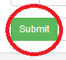 **"Click"**

Figure Click

A red circle means that the user should click the circle input.

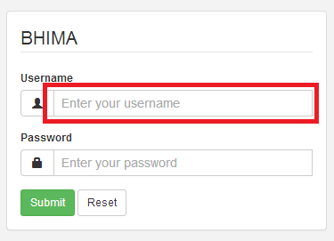

Figure Type

**"Type"**

A red square around an input means that users should type a value into the input.

**Selecting a Project**

Bhima facilitates the management of projects. In bhima, projects represent classifications of transactions. Recurring groups of transactions which may take place at the same location, for the same purpose, or are intended to be distinguished from the regular flow of business may be assigned to a project for analysis and control. If a user has the ability to enter data in multiple projects, they will have to choose which project they wish to work in at the beginning of each operating session.

1. **Log in**

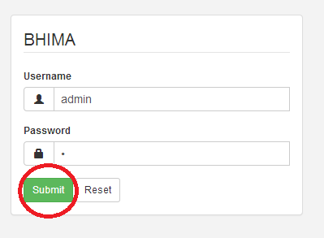

Figure Log In Interface

Enter your user name and password in the boxes, then click submit.

1. **Select a Project**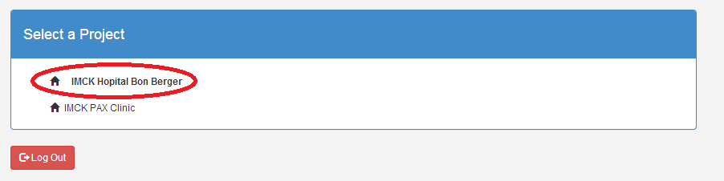

Figure Click to select a project

All the projects the user has access to will be listed in a panel "Select a Project". Click the text of the project you wish to use for your input session.

1. **Begin using the application**

Congratulations! You are now correctly logged in and may begin inputting data with the chosen project.

**Navigating the Application**

Bhima is an easy application to navigate. The interface is divided into two main parts. 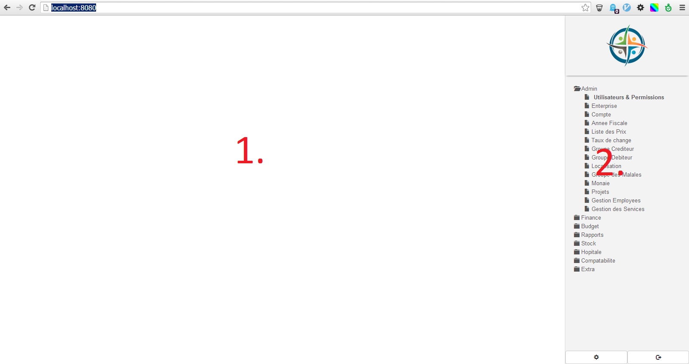

Figure Bhima's Interface

1. **Module Panel :** This section will change with every module. It is where the module's contents are displayed and is mostly where the user will interact with the application.
2. **Navigation Panel :** This section contains the *navigation* *tree* of all modules that the user has permission to use. Clicking the text of any item in the navigation tree will cause the module's contents to be displayed in the module panel. Modules are grouped into folders which open with a click. The navigation panel also contains two buttons at the bottom of the panel, which perform application actions.

**Using the Navigation Panel**

The navigation panel contains links to every module in the bhima application. Modules are grouped according to functions in folders such as the "Admin" folder displayed below. In the first image, the folder is closed, hiding all modules in the Admin category. After the folder is clicked, an image of an open folder shows that the contents are accessible.

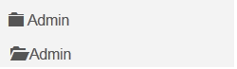

Figure Open and Closed states of a Folder

Clicking the folder will cause it to open exposing a list of modules for the user to select. For example, below, the folder "Hopitale" is clicked first to open the links to its modules, then the module "Enregistrements des Malades" is opened in the Module Panel.

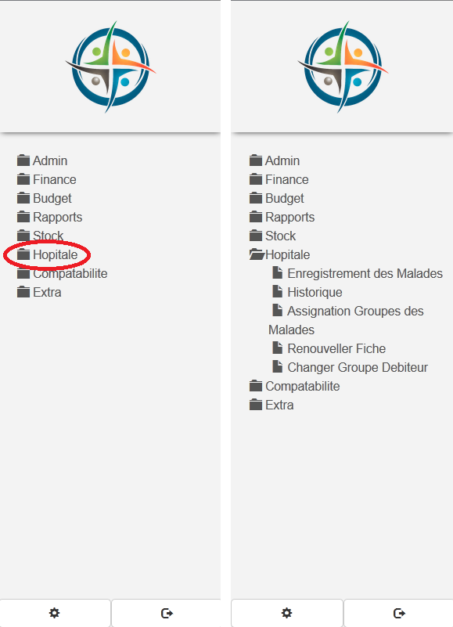

Figure Click to open the folder "Hopitale" and reveal the "Enregistrement des Malades" module.

Selecting a module from the navigation tree will open the module in the Module Panel. For example, clicking "Enregistrement des Malades" opens the module for use:

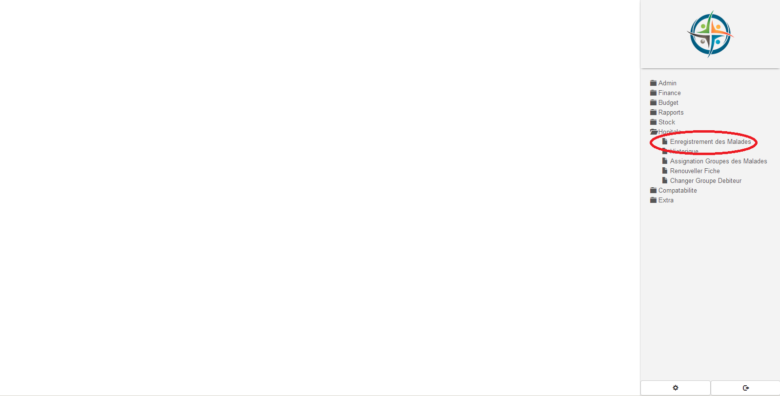

Figure Click to open "Enregistrement des Malades"

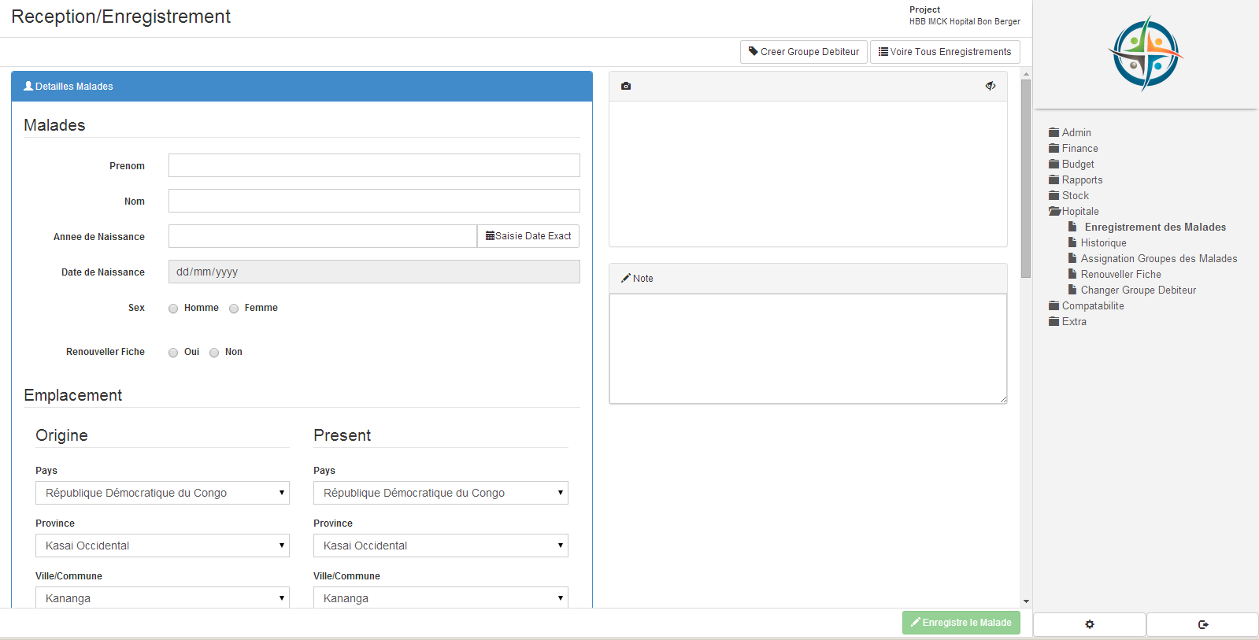

Figure Module "Enregistrement des Malades" open for use

**Using a Module**

All work in bhima is done through specific pages called *modules*. Modules provide interfaces for displaying, recording, and editing data. Most often, modules are opened by selecting a link on the *navigation tree*, as previously described.

Once a module is open, the interface is broken into four distinct parts.

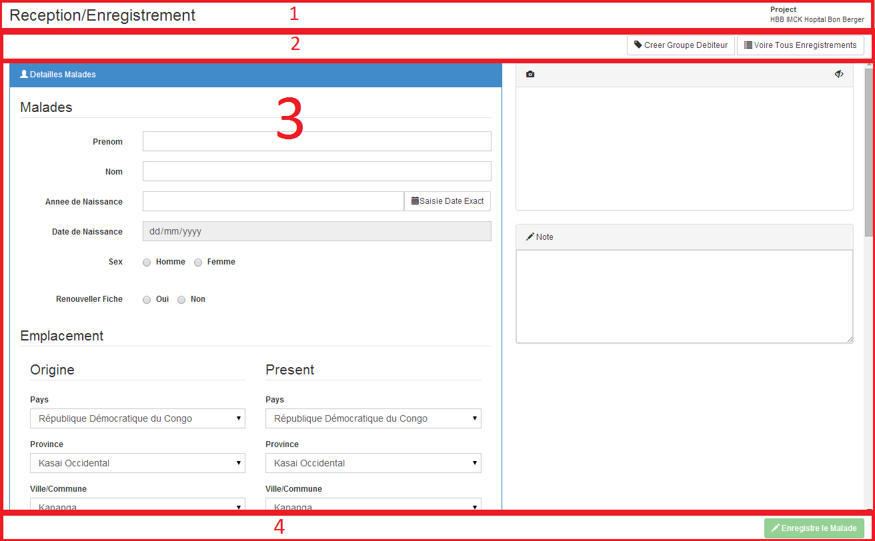

1. **Header** : The header contains the module title.
2. **Utility Bar** : The utility bar contains actions such as "Print", "Create" and "Edit" which allow the user to interact with the data in the module.
3. **Display** : The main contents of the module. Contains forms, grids, and inputs that the user interacts with. Every module has the main display page.
4. **Footer** : Contains submit buttons to allow the user to advance to different sections of the module or submit data to the server.

**Using the Sale Module**

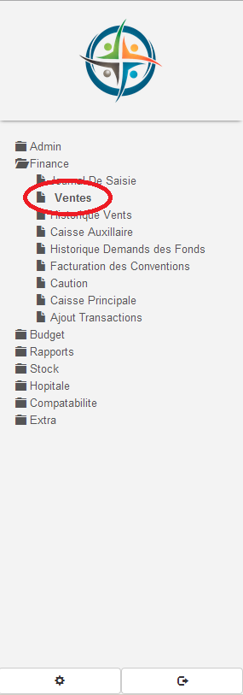 Bhima records sales to patients using the module "Sale" under the folder "Finance".

Figure Click to open the sale module

The sale module creates bills against patients that frequent the hospital. The example on the left shows where the sale module is located in the tree.

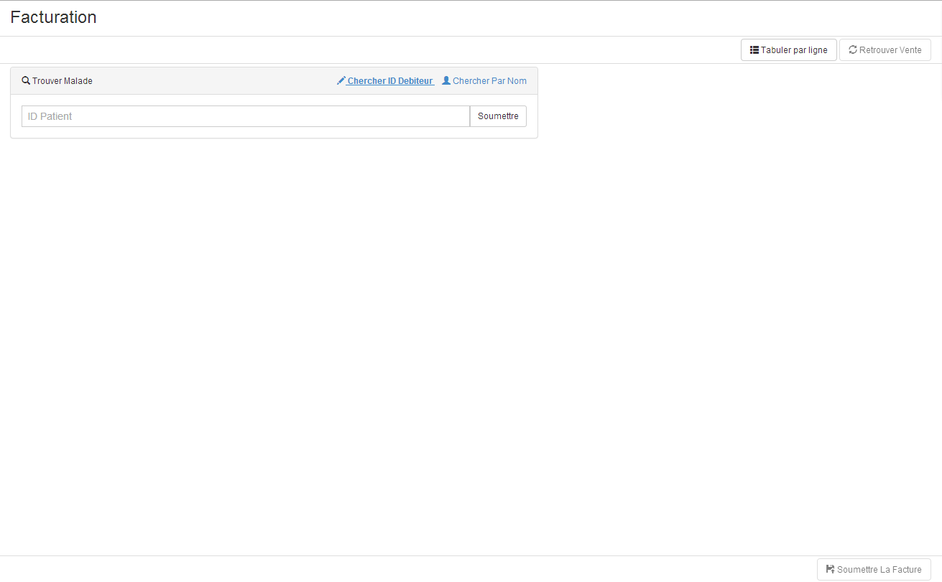

Figure Sale Step One : The blank sale module

The